01 - Environment Setup
Date: October 11, 2026 Status: Complete - VM created, not yet booted
Goal
Create the virtual machine that will become the Domain Controller (DC) for the Active Directory lab, and design the network the lab machines will use.
Tools Used
Tool | Purpose
VirtualBox | Hypervisor that runs the lab VMs
Windows Server 2025 Evaluation ISO | Operating system for the Domain Controller (free 180-day evaluation from Microsoft Evaluation Center)
VM Specifications
Setting | Value
VM name | AD-DC01
Operating system | Windows Server 2025 Standard Evaluation (Desktop Experience)
RAM | 4096 MB
CPUs | 2
Virtual disk | 50 GB, VDI, dynamically allocated
Unattended install | Skipped (manual installation, to learn each setup step)
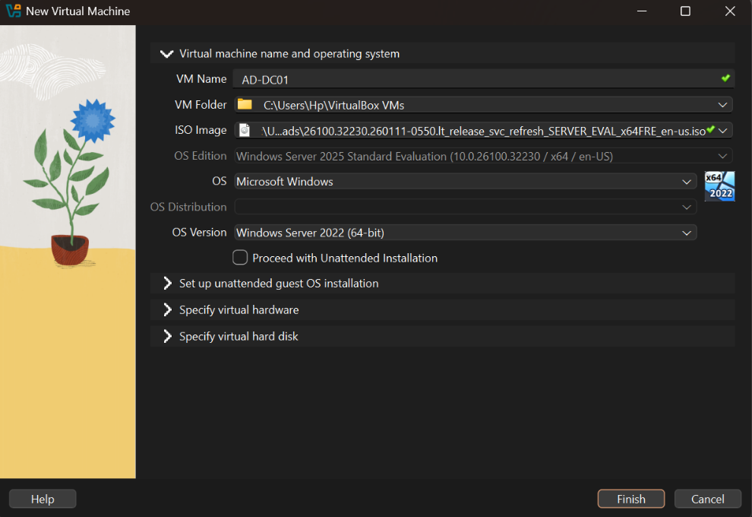

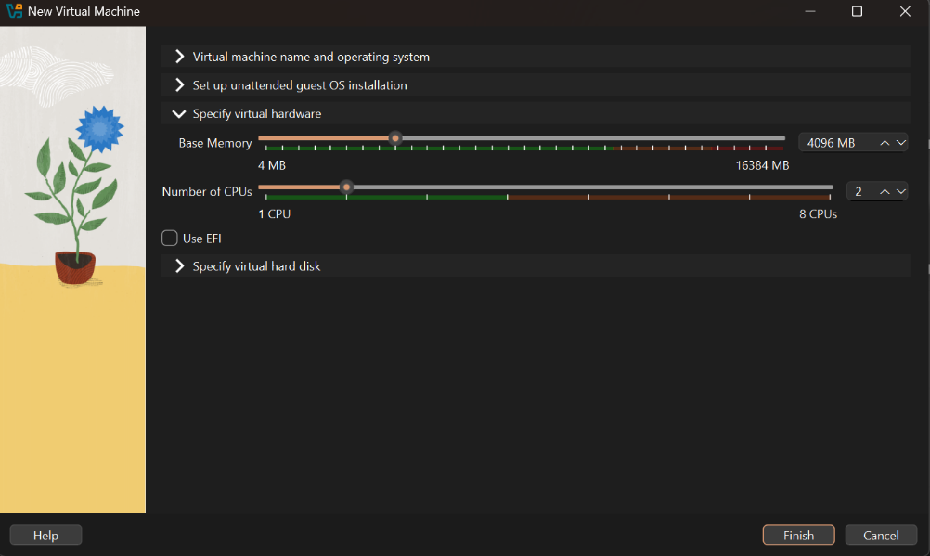

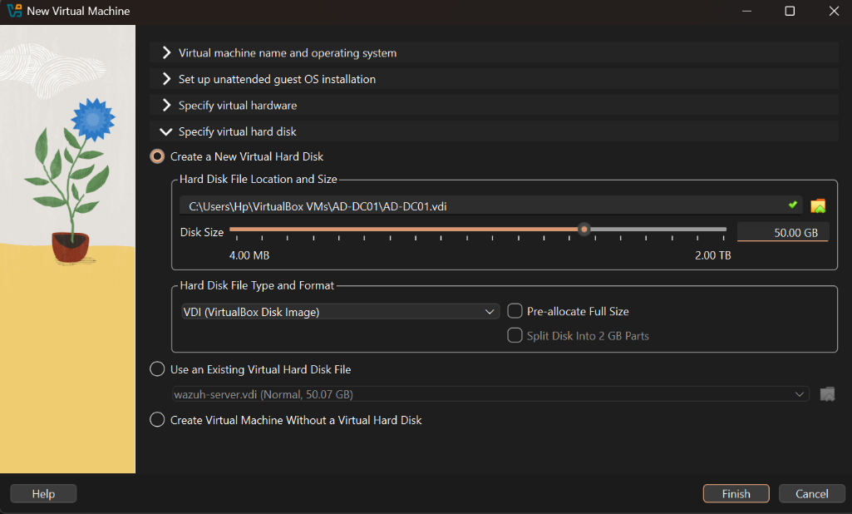

Network Design
The VM has two network adapters, each with a different job:
Adapter | Type | Purpose
Adapter 1 | NAT | Gives the server internet access for Windows activation and updates
Adapter 2 | Internal Network (adlab) | Private network where the server and the client will talk to each other, isolated from my real home network
Keeping domain traffic on an isolated internal network means any attack simulation I run later cannot reach my real network or other devices.
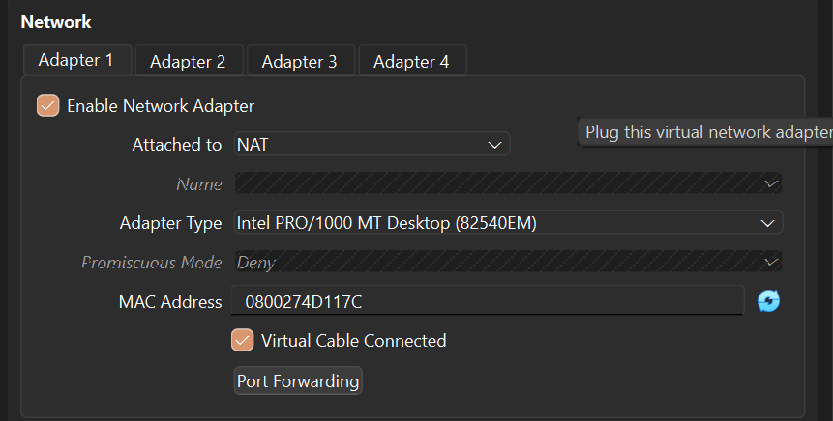

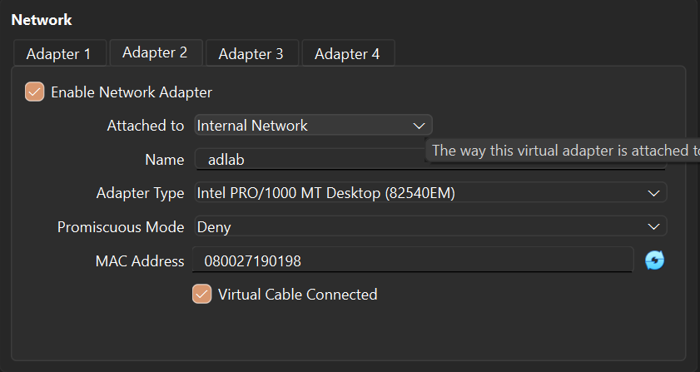

Final VM Summary
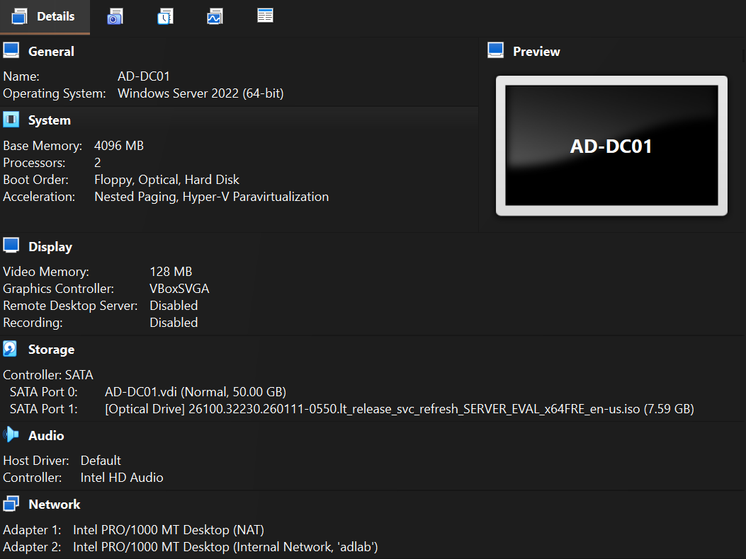

Problems Faced
ISO download timeout. The Microsoft Evaluation Center page loaded and registration worked, but the file download failed with ERR_CONNECTION_TIMED_OUT from the download server (software-static.download.prss.microsoft.com). This was a connection issue between my network and Microsoft's file server, not a problem with the page itself.
Fix: Retried the download using a different network route until it succeeded. The Windows Server and Windows 11 ISOs together took about 4 hours to download.
Disk size default. VirtualBox suggested a disk size of about 27 GB, which is too small for Windows Server plus updates and logs. I increased it to 50 GB.
Next Step
Boot the VM from the ISO and install Windows Server, then rename the machine to DC01 and configure a static IP on the internal network adapter. See 02-domain-setup.md (coming next).

